

School of Computer Science

COMP-2707-91- Advanced Website Design

Summer 2021

2707 Final Report

Join Team

Juntao Ma

104670705

1. Introduction

2. Features of Application

3. Tools & Techniques

4. Implementation Details (You may provide brief details how you created your application in steps along with screen shots)

5. Conclusion

6. References

2. **Features of Application**

**The main features:**

* Users' login (company/ employee) register & login
* Human resource departments edit company information
* Human resource departments post hiring information
* Applicants edit their information
* Applicants upload their resume
* Applicants submit their resume to the company hr.
* Hr. get notification and read the resumes
* Hr. decides whether the applicants are passed or not
* Applicants get the result and they decide whether to go to the interview

**Each page with screenshot:**

Login page:

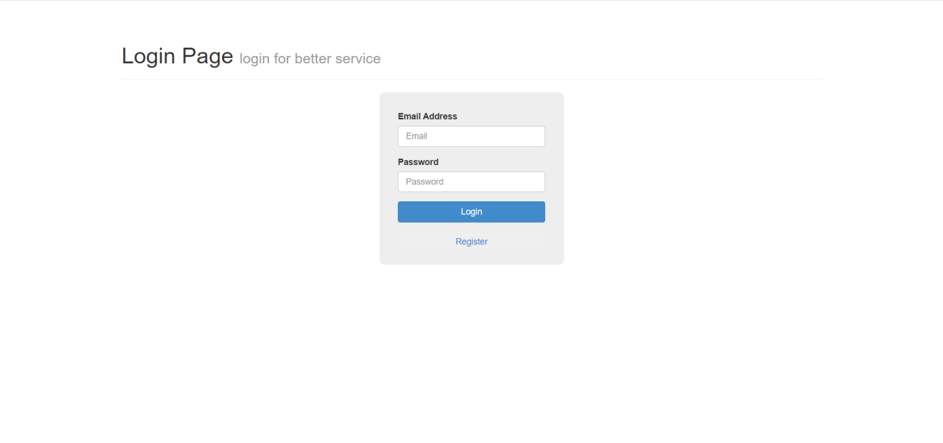

Either Applicants and Company login in this page by enter email and password.

Use the register button jump to the register page.

Register page:

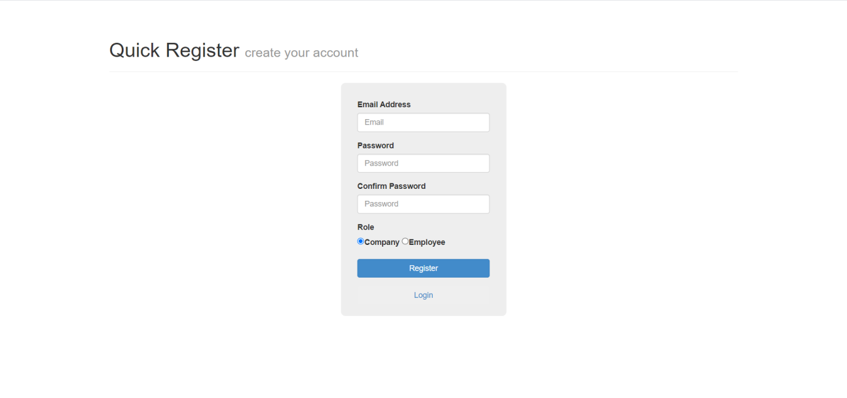

User can choose which type of account he wants to register. After registration finished, user needs to login again to go to the main page.

Applicant's account: [594115018@qq.com](mailto:594115018@qq.com) ; Password: 123

Company’s account: admin@gmail.com ; Password: 123

Applicant's page:

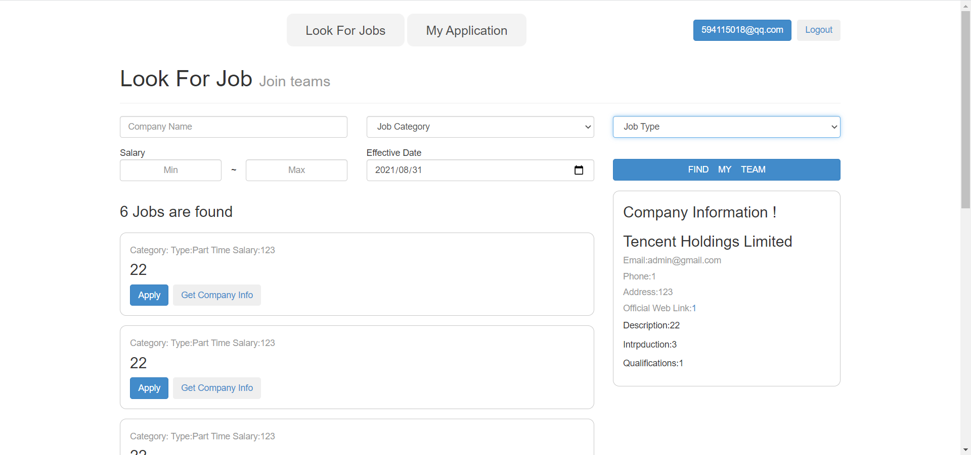

There are some filters above the results, which includes the company name, job category, job type and salary. When users click one of those “Get Company Info” button, the information will show on the left of the page. And they can click “Apply” button to send the request and add that job to their job list.

To go to the job list, user should click the “My application” button.

My application page:

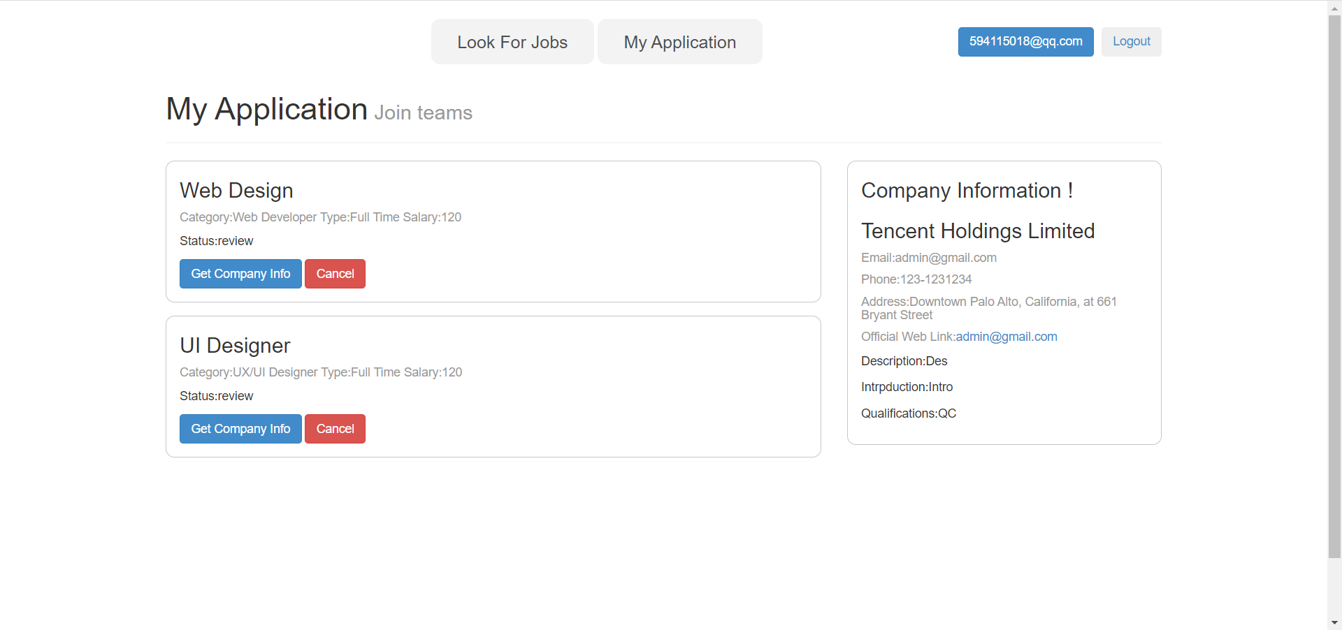

Applicants are able to see all their applications here. They also can cancel any of them by click the “Cancel” button. The company information is shown on the left.

They also can click the button on the top right to go to their personal information page.

Applicant's personal information page:

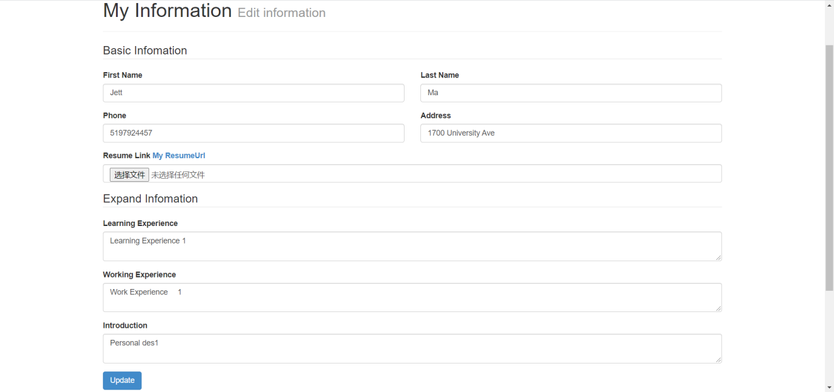

Applicants are able to edit their information in this page, includes uploading their resume document.

Company Page:

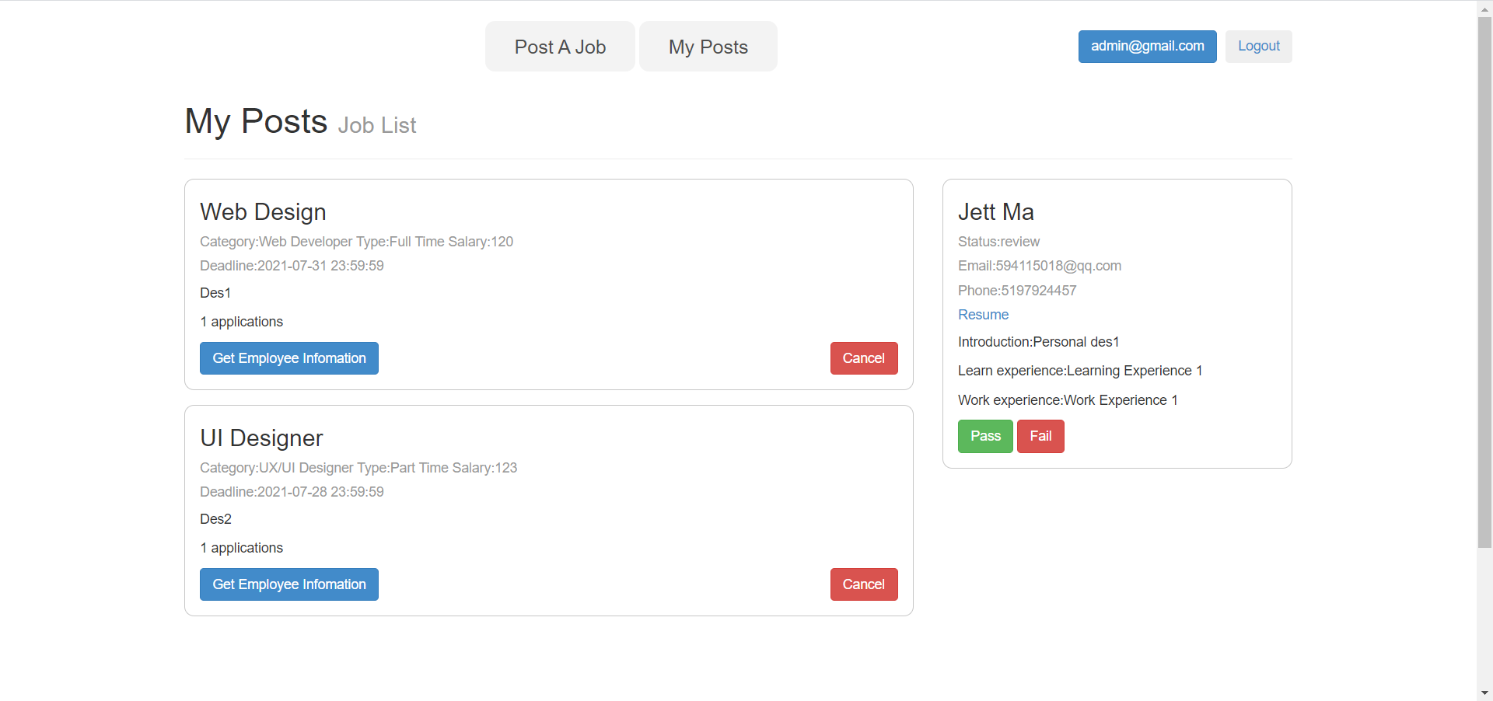

This is the page when the recruitment officer login. They are able to see all the application to their company. They can click the “Get Employee information” button to see the information on the left of the page. And they have choice to pass or fail the application.

The button “Post A Job” leads user to another page that the recruitment officer post a new job.

Job Posting Page:

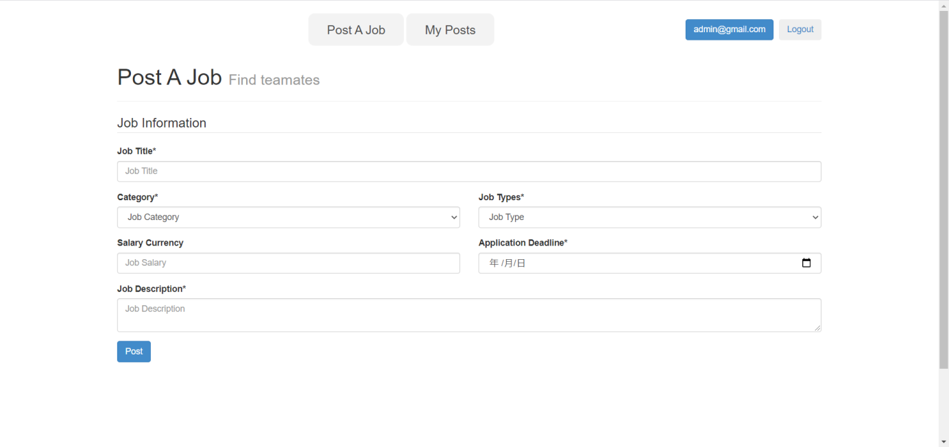

Recruitment officer can post new jobs on this page. The company of the job will be the same as the officer.

They also can click the button on the top right to go to their company information page.

Company Information Page:

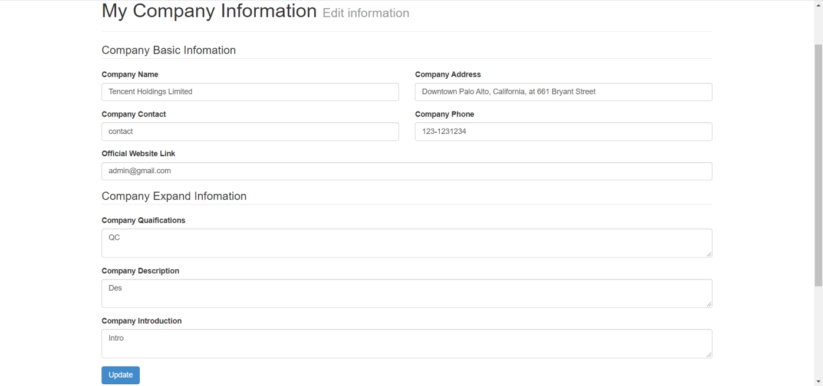

Applicants are able to edit their company information on this page.

After the officer pass one application, the status will change in applicant's view.

